Are you ready to benefit from coaching?

Coaching is for you if there is a gap between where you are and where you want to be, what you have and what you want. Coaching is for you if you are willing to change and open to try new ways of doing things. Use the questions below to help you decide if you are ready to benefit from coaching.

- Do you have goals, skills, or projects you want to achieve?
- Do you have choices to make but the options to pursue seem confusing?
- Do you desire greater clarity and confidence?
- Could you benefit from additional support with reaching your goals?
- Are you ready to commit time to your personal development?
- Could you use more energy-giving partnerships in your life?
- Do you want to accelerate the results in your life, profession, and/or business?
- Are you willing to make changes to have the life you want?
- Could you benefit from receiving an honest, outside perspective?
- Would it improve your life to have an accountability partner to keep you on track with what you have committed to accomplish?

If you answered YES to 4 or more of these questions,
then YOU are ready to benefit from coaching.

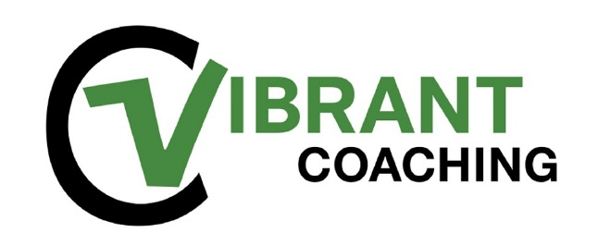
Be the BEST you on purpose

